NWF Rural Health NewS 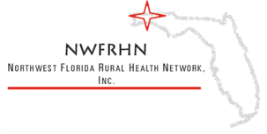

Issue 13 / Jan – Mar 2025 Northwest Florida Rural Health Network, Inc.

Upcoming Health Events
Santa Rosa County Department of Health

“Public Health is critical to the success of any community. As the Florida Department of Health in Santa Rosa County, we are well-positioned to show the broad reach and benefit of helping take care of one another. We have the staff, resources, partners, and inspiration to champion the causes our residents are concerned about. Let us engage with you to build trust and invite more groups to join the Public Health team.”
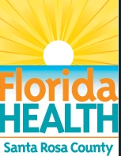

news Information

Network will have a table at the annual EREC event on
Saturday, April 26, 2025 at Wallance Lake K-8 School from 8am to 10am


Services
• Signing up for Food Assistance with DCF

• Transportation Services

• Veteran Service Location & Information

• Assistance with Medicare Part D and Supplemental Insurance through Agency on Aging

• Health Fairs / Provider Info
Contact Us
Northwest Florida Rural
Health Network, Inc.
3927 Hwy 4 Ste 203
Jay, Florida 32565

Phone (850) 675-4787
Fax (850) 675-4181

northwestfloridaruralhealthnetwork.org
MISSION
“The mission of the Northwest Florida Rural Health Network is to provide a venue for collaboration of efforts among all interested parties to ensure that quality health care is available and efficiently delivered to all persons in the communities we serve.”
Do you need transportation services?

The Northwest Florida Rural Health Network has partnered with ITL Solutions to offer non emergency medical transportation services to residents of the Jay and Century areas.

Services are currently operational Monday’s, Wednesday’s, and Friday’s from 6 am to 2 pm. Contact the Network Office for more information.


Transportation
The Network Office will be closed for the following upcoming holidays:
Memoria Day May 26th.

